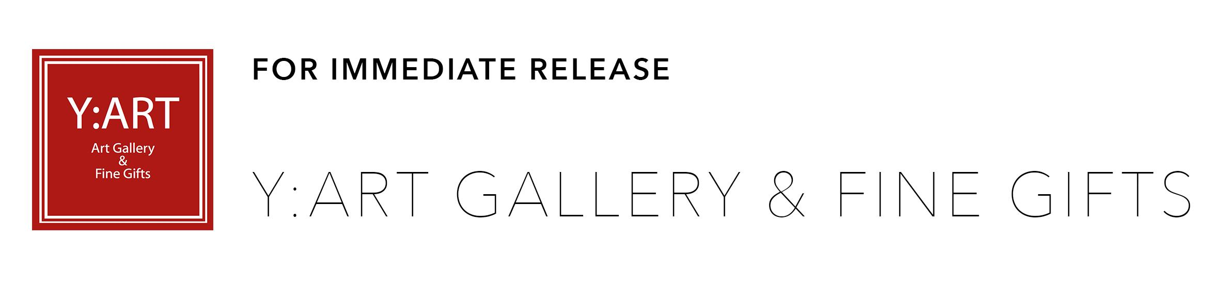
JOAN SCHEIBEL
GINA FALCONE SKELTON
FARIDA HUGHES
MARCH 13 - APRIL 27, 2019

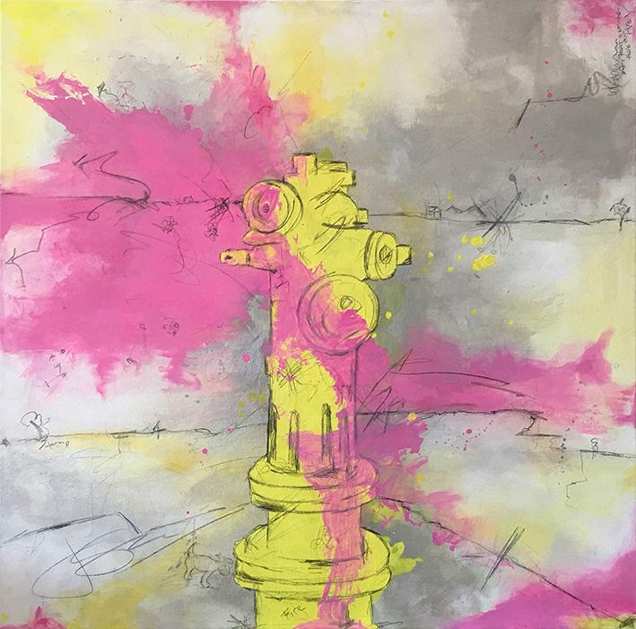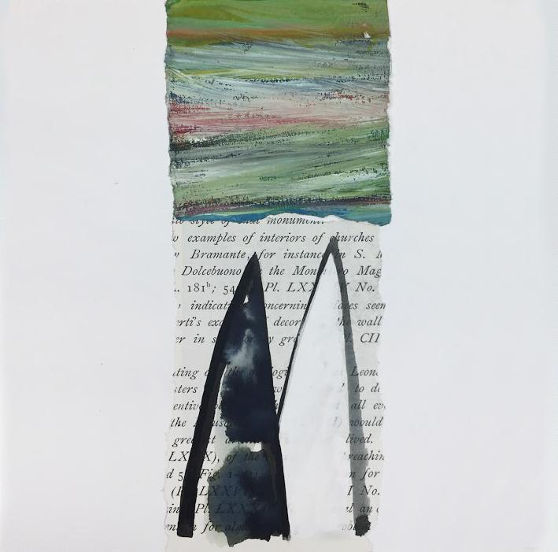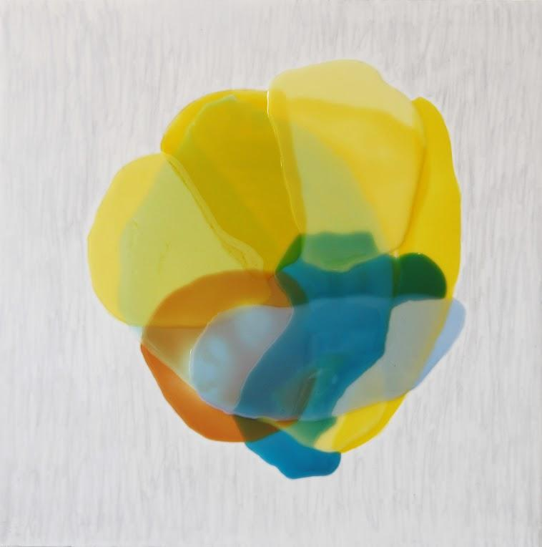

Y:ART Gallery is pleased to announce an exhibition of work by Joan Scheibel, Gina Falcone Skelton and Farida Hughes. The Opening Reception will be held on Saturday, March 16, 2019 from 6-9pm. The installation highlights a distinctive body of work from each artist that speaks to the layered complexity of the human experience.

By bringing together these three artists and their array of styles and mediums, this exhibition invites us to examine the relationship between individuals and their role in the collective whole. The work pieces together a story of human connection, community, and divine creation. It explores the dynamics of culture through the past and the present, and exposes the wire or thread that connects us all, even through the tension that divides us. Each artist has a unique and distinctive method of combining materials and magnificent colors to deliver a reflection of the multi-layered reality of existence. In the current climate of divisiveness, the work seen here inspires the viewer to seek the interconnectedness in the world surrounding them.

To learn more about the artists, their inspiration and technique, an Artist Talk will be held on Saturday, April 27 from 4-6pm.

ABOUT THE ARTISTS

JOAN SCHEIBEL
Joan Scheibel works in layers, letting each layer dry before painting another, usually working from light to dark. She is often asked about her process. She feels that it is not really a process so much as a way of life. She sees people and things that move her in life, a shadow, a dance, a church or just everyday events. Scheibel takes these ideas and images and reimagines them on canvas. In her words, “Suddenly and finally, the image that grabbed me, is reconstituted to grab you. The universal eye.”

Scheibel is a contemporary abstract painter currently living and working in Los Angeles. Scheibel received a full scholarship from the prestigious Otis/Parson College of Art and Design and would later study Illustration at Platt College of Design. Scheibel established a prominent seventeen-year career in graphic design, owning a business that was at the forefront of album packaging, branding, and advertising. Turning her attention inward for a more personal form of expression, Joan has pursued a fine art career for nearly a decade. Her work quickly earned acknowledgment from collectors, peers, and galleries throughout California, New York, New Mexico, and Las Vegas, NV. She is a consistent winner of the juried “ArtSlant Showcase” awards given to emerging and mid-career artists that exhibit both great potential and commitment to their practice.

GINA FALCONE SKELTON
Gina Falcone Skelton is a painter living in Baltimore, MD. She has worked primarily in oil on canvas, employing both figurative and landscape imagery in a nonliteral approach to painting. Her latest work (2014-present) represents a new direction with pieces made in a new medium: torn paper on paper, the latest incorporating marks made by the artist’s hand. These paper paintings continue Falcone Skelton's exploration of the individual and collective histories of people as they encounter both the external landscape and their hidden, interior worlds. Using literal and abstract imagery as iconic references to shared ideas, the work explores the human drive to create a narrative revealing the profound in the ordinary, the connectedness between the unconnected, the hidden meaning of life.

Prior to a solo exhibit of the first 9 large-scale paper pieces at Stevenson University In 2017, the new work was featured in Baltimore Style Magazine, April 2017, and at BmoreArt.com in January 2017. She has been represented in solo and group shows by galleries in Baltimore MD, Richmond VA, Chicago Il, New Orleans LA, and Key West FL, and Annapolis MD.

FARIDA HUGHES
Farida Hughes' lively and intriguing abstract paintings take their inspiration from the gathering and dispersing of crowds. Arranged as aerial landscapes, shapes group and mingle in response to, and cooperation with, their natural or architectural environment, referenced by the negative spaces in the paintings. Farida's interests in community engagement, collective movement and the recording of histories over time, inform her work in oils on canvas and watercolor on paper.

An American abstract artist working in mixed media, oil, and resin paint on panel, Hughes developed her mixed media style after many years of painting with oil paint and experimenting with oil painting mediums. She studied Studio Art and English at Fordham University in New York and received an MFA in Painting from the University of Chicago. Her work is exhibited widely in galleries and art centers and is included in several private and corporate collections, including Target, United Health Group, and Chesapeake Capital. Hughes is a 2013 recipient of an Artists’ Initiative Grant from the Minnesota State Arts Board. She has worked with many arts outreach groups and grass-roots community arts endeavors and is a current Board Member of the Banfill-Locke Center for the Arts.

___________

Y:ART is a contemporary gallery established in 2015 by Julia Yensho. It provides a forum for the art and culture of our time by presenting network and ideas through curatorial practice, artist representation, and by encouraging artistic collection. Y:ART Gallery is in the forefront of a new and exciting renaissance in Baltimore’s Highlandtown Arts District. The gallery has been responsible for many important solo and group exhibitions that have launched and sustained the careers of featured local and regional artists. Public programming within the gallery consists of artist talks and expert lectures on current exhibitions; all free and open to the public. Y:ART's gallery store features over 70 local and regional artisans who specialize in handcrafted fine art gifts including: jewelry, pottery, glass, wood, textiles and metal work. The walls are covered with extraordinary unique artworks and sculptural pieces that would impress any collector. This unique space is open for artist showings and workshops, and the gallery is also available as a venue for private functions or social gatherings.

For interviews with the artists, additional images, and general inquiries, please contact the gallery at 443-928-2272 or yartgallery3402@gmail.com

Y:ART Gallery & Fine Gifts
3402 Gough Street
Baltimore, MD 21224
yartgalleryandfinegifts.com
facebook.com/YARTBMORE/
instagram.com/yart_gallery_and_fine_gifts/

